**Name :** Poojitha Talari

**Trainer Name :** Harshee Pitroda

**Course :** Basics of Python and ML

**Date :** 06-06-2022

**Q1**



**Program:**

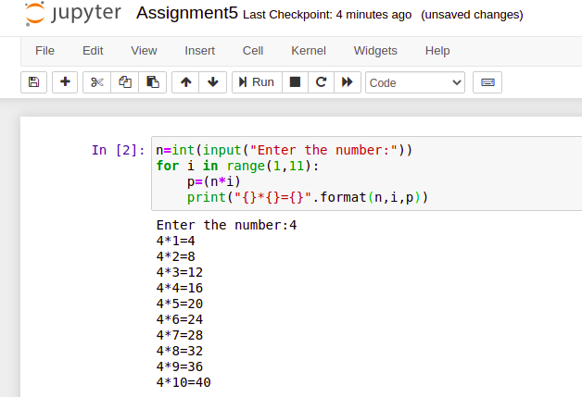

**Q2 :** https://www.hackerrank.com/challenges/python-loops/problem.

**Program:**

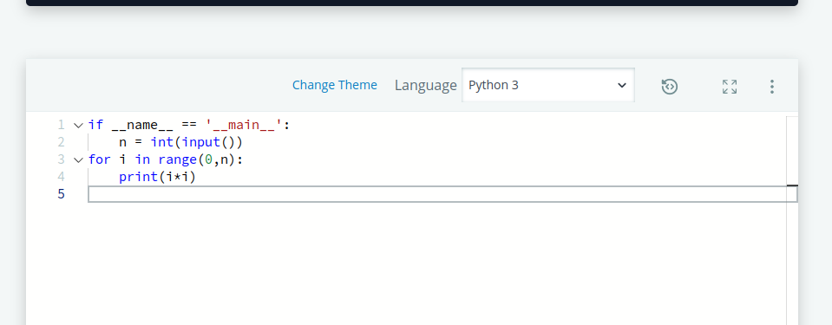

**Output:**

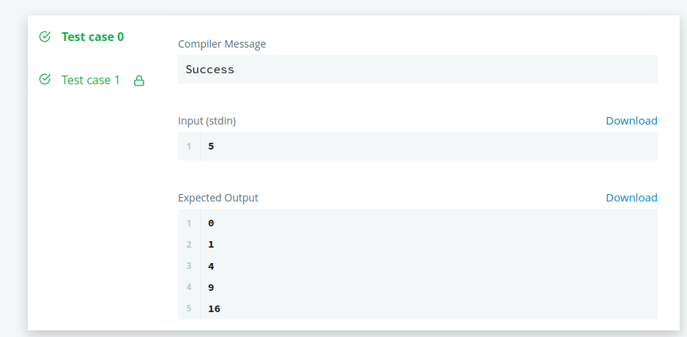

**Q3 :**

https://www.hackerrank.com/challenges/py-if-else/problem?isFullScreen=true

**Program:**

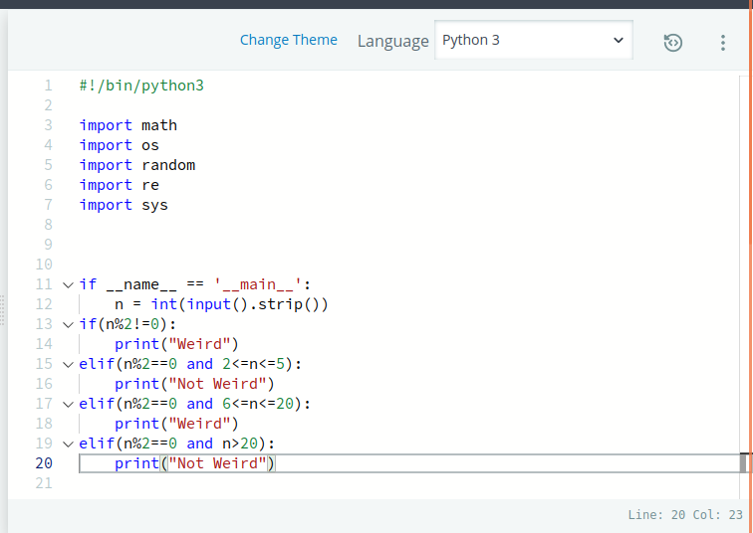

**Output:**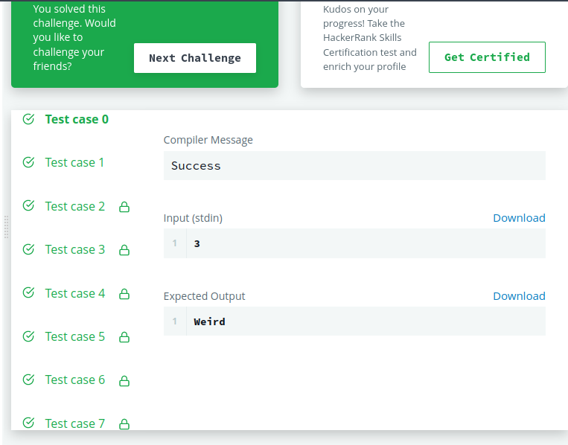

**Q4 :**

https://www.hackerrank.com/challenges/whats-your-name/problem?isFullScreen=true

**Program:**

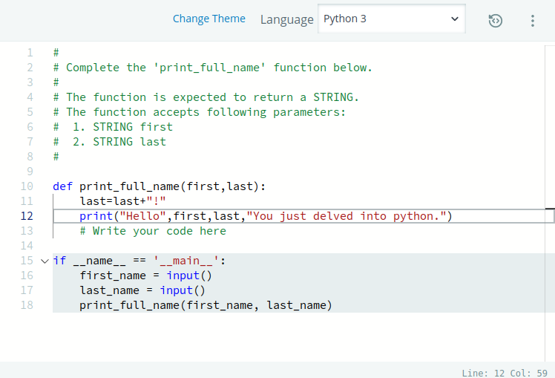

**Output:**

